

Foundations of Programming

Assignment No.: 17
PROBLEM STATEMENT: To accept the number of terms and find the sum of the sine series.

OBJECTIVE:

- To understand the concept of mathematical series in programming.
- To implement sine series using C programming.
- To practice loops and arithmetic operations.
- To learn the use of factorial and power calculations in C.

THEORY:
In mathematics, the sine function can be expressed as an infinite series called the Taylor series expansion. The sine series is represented as:
sin(x) = x − x^3/3! + x^5/5! − x^7/7! + ...

In this program, the user enters the value of x and the number of terms. The program calculates the sum of the sine series up to the specified number of terms using loops. Factorial and power operations are used to compute each term of the series.
PLATFORM: Linux

INPUT: Value of x and number of terms.

OUTPUT: Displays the sum of the sine series.

SAMPLE INPUT:
Enter value of x (in radians): 1
Enter number of terms: 5

SAMPLE OUTPUT:
Sum of sine series = 0.841471

CONCLUSION: Thus, the C program successfully calculates the sum of the sine series for the given number of terms.

FAQs:
- What is a sine series in mathematics?
- Why is factorial used in the sine series?
- Why does the sine series have alternating signs?
- Which header file is required for power functions in C?
- How does increasing the number of terms affect accuracy?
Code
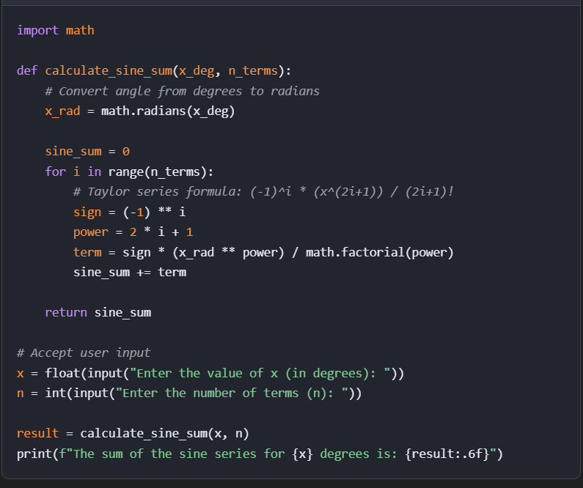
FAQ’s
- The sine series is defined as a mathematical series that uses sine functions as its basic building blocks to approximate periodic, oscillatory phenomena. It is often part of the Fourier series, which can represent a wide range of continuous curves, including those with discontinuities, through the summation of sine terms along with cosine terms.

- As for factorials, it's because they grow so fast, faster than exponential functions! This allows the remainder to quickly approach zero. Taylor expansion is essentially expressing a complex function as a linear combination of several simpler functions!

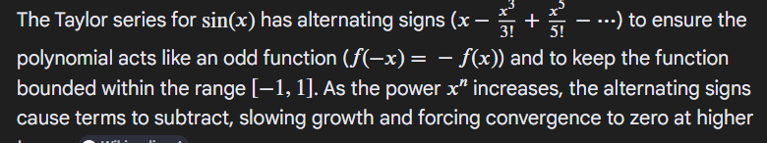
4
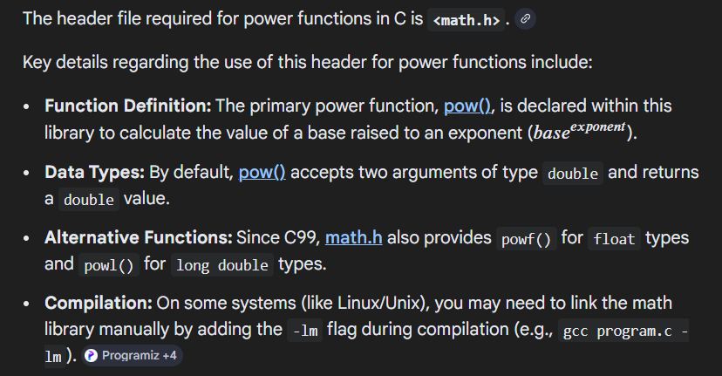

5 Increasing the number of terms in a Taylor series (or similar approximation series) improves the accuracy of the approximation, but it is a "double-edged sword" that depends heavily on the context, particularly how close the point of interest is to the expansion point

